Fishburn Primary School

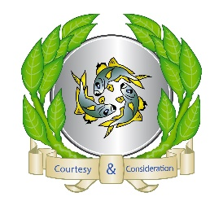

Say STOP to Bullying!


Anti – Bullying Policy and Child on Child Abuse for
Children
September 2026

Person Responsible: Richard Parkin
Next review Date: September 2027
What is bullying?

In our School a bully is someone who hurts someone more than once, deliberately using behaviour which is meant to hurt, frighten or upset another person.

There are different types of bullying. Bullying can be:

- Emotional: Hurting people’s feelings, leaving people out, making people feel bad.
- Physical: Punching, kicking, spitting, pushing, theft, touching or hurting parts of the body which are private.
- Verbal: Teasing someone, calling someone names, being rude to someone.
- Racist: Calling someone racist names, graffiti.
- Cyber: Saying unkind things to someone in a text, email or on social media.

When is it bullying?

Bullying is when it happens several times on purpose.

We can remember this using STOP.

Several
Times
On
Purpose

Sometimes people are unkind or make cruel comments to make others laugh. They think it’s funny without realising it is hurtful.
It is so important to
Think before you speak!
Who can I tell?

There are lots of people in School who can help.

You can tell:
- A friend
- A family member
- A School Council member
- Your Class teacher
- Any adult in school who you trust
- Someone you trust in or out of school
- You can show how you are feeling using the Zones of Regulation and your Safe Circle

MOST IMPORTANTLY if you feel you are being bullied:

Start
Telling
Other
People

What should I do if I am being bullied:
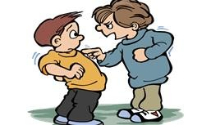
- Ask them to stop if you can
- Use eye contact and tell them to go away
- Ignore them
- Walk away
- TELL SOMEONE

Remember do not:

- Do what they say
- Get angry or upset
- Hit them
- Think that it is your fault
- Think you will get into trouble
- Hide it
- Retaliate

What should I do if I see someone else being bullied?

- Don’t walk away and ignore it.
- Tell the bully to stop if it is safe to do so.
- Don’t stay quiet or the bullying will not stop
- Don’t get angry
- TELL SOMEONE

The Headteacher, Governors, Staff and School Council will work together to:

- Make our School a place where everyone can feel happy. That means no bullying allowed.
- Help everyone to get on with each other and we believe that everyone has the right to feel safe and be themselves.
- You can see how we promise to keep you safe in our 10-point charter – next to your Safe Circle poster

